CARELY
The core model behind user accounts
Instead of two account types, you now have one account type with an optional Provider layer:
- Everyone signs up the same way, as a general user who can search and book services.
- Anyone can later tap "Become a Provider" from their profile this doesn't create a new account, it attaches a provider profile to the existing one.
- Because it's additive, not a switch, a provider keeps full booking rights too a nanny on your platform can just as easily book a cleaner for her own home. Same login, same identity, two capabilities.
This actually corrects something in the earlier design: I had modeled Household and Caregiver as separate subclasses inheriting from User (via generalization). That doesn't work anymore, since a person can be both at once — inheritance assumes exclusive categories. The fix: a single User class with an optional, attachable ProviderProfile (composition, not inheritance) — User "1" -- "0..1" ProviderProfile.
Simplified sign-up (everyone, same form)
Keep this minimal, as you said:
- Full name, phone number, email, password + confirm
- City/neighborhood
- Preferred language
- Terms & Privacy checkbox
No service-related questions here at all — that's what the upgrade flow is for.
"Become a Provider" upgrade flow (one screen, checkbox-driven)
Field | Notes
Services offered | Checkboxes, multi-select: Babysitting, Home Nursing/Elder Care, Indoor Cleaning, Outdoor Cleaning, Gardening, Dog Walking, Housekeeping — a provider can check several (e.g. Babysitting + Indoor Cleaning)
ID Card or Passport | Upload
Police Clearance | Upload
References | At least 2 (name + phone), "Add another reference" button
Service area | Neighborhood/radius
Base rate | One general hourly rate to start — per-service rates can be refined later in profile settings, not required at signup
Submitting puts the provider profile into "Pending Verification." Once admin approves the ID + police clearance + references, they're listed as a Verified Provider and can start receiving bookings. Additional services can be checked on/off anytime from profile settings; no need to redo the whole form.
Two separate trust tiers worth naming explicitly
Your message actually describes two different trust signals, and keeping them distinct will save you confusion later:
- Verified (mandatory, gates being listed at all) : ID + police clearance + references, approved once at signup. This is baseline safety, not a badge of skill.
- Certified (optional, provider-initiated, the Instagram-style tick) : a mark of proven quality, not just safety.
Here's that certification flow:
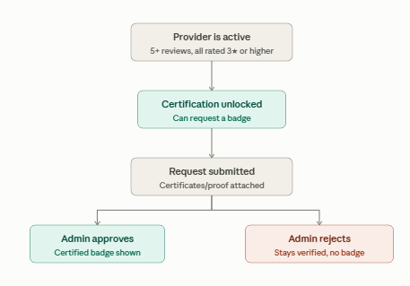
Figure 1 Trust tiers workflow

HOW THE MVP WORKS
Single-Session Booking
1. Request
- Household selects a caregiver and submits a request for one date + time window.
- No payment is taken. Caregiver's calendar shows a temporary hold for that slot.
2. Caregiver response (within response window, e.g. 24h)
- Accepts → proceeds to Step 3.
- Declines / no response → hold clears, no charge occurred, household is shown alternative caregivers.
3. Payment
- Full session amount is charged via mobile money (household approves via PIN).
- Funds move into escrow. The slot locks permanently on the caregiver's calendar.
4. Day of service
- Caregiver arrives and enters the session's OTP to confirm on-site presence.
- OTP entered → session marked "in progress."
- OTP never entered (caregiver never showed) → session flagged as no-show; see cancellation/no-show handling below.
5. Session end → confirmation window opens
- The moment the scheduled end time passes, a 24-hour confirmation window starts automatically (not tied to the caregiver tapping anything).
- Household is prompted to confirm the service was completed.
6. Fund release
- Household confirms (regardless of whether the caregiver also marked it complete) → funds release to caregiver immediately.
- Household takes no action for 24h → check OTP status:
  - OTP was verified at arrival → auto-release to caregiver.
  - OTP was never verified → funds are not released; returned to household instead (objective evidence the caregiver never arrived).
Cancellations — single session
- Before caregiver accepts: household or caregiver can cancel freely; nothing was charged.
- After acceptance, before the session date: household can cancel; since payment was already captured, refund the full amount (minus any small non-refundable processing fee you choose to define). Caregiver's calendar slot is released.
- After the session has started/OTP verified: no cancellation — the service is underway; the completion/release flow applies.

Recurring Booking
1. Request
- Household submits a request with: start date, selected days of the week, time window, and duration (weeks). System resolves this into a full list of individual sessions (e.g. "9 sessions, Aug 3–21").
2. Caregiver response
- Accepts → the entire schedule is confirmed in one action; all sessions lock on the caregiver's calendar at once.
- Declines / no response → whole request clears, no charge, household picks another caregiver.
3. Payment — weekly cycle
- At the start of each week covered by the booking, a payment request is sent to the household for that week's sessions.
- Household approves via MoMo PIN → that week's amount moves into escrow.
- This repeats automatically at the start of every subsequent week for the length of the booking.
4. Each session within the week
- Same as the single-session flow: caregiver enters OTP on arrival → session ends → 24h confirmation window opens (schedule-triggered) → household confirms or lets it auto-release, with the OTP-verified check gating auto-release.
- Sessions are released individually — a caregiver who completes Monday and Wednesday but misses Friday still gets paid for Monday and Wednesday on schedule; Friday's portion isn't released without a verified OTP.
5. Cycle repeats until the last week in the booking's date range is reached.
Cancellations — recurring booking
- Before caregiver accepts: free cancellation, nothing charged.
- Cancel an entire future week (not yet billed): simply don't send that week's payment request; those sessions are removed from the schedule.
- Cancel mid-week, after that week was already paid: refund only the portion for sessions in that week that haven't happened yet or weren't completed/OTP-verified; sessions already confirmed/released stay paid.
- Cancel a single occurrence within an ongoing recurring booking (e.g. skip one Wednesday, keep the rest): remove that specific session from the schedule; if its week was already billed, prorate the refund for that one session only — the rest of the week's sessions continue normally.
- Caregiver cancels mid-booking: any future unbilled weeks simply don't get charged; any already-paid-but-undelivered sessions in the current week are refunded to the household.

HOW CARELY’S BOOKING REQUEST INTERFACE SHOULD BE (Multistep Flow)
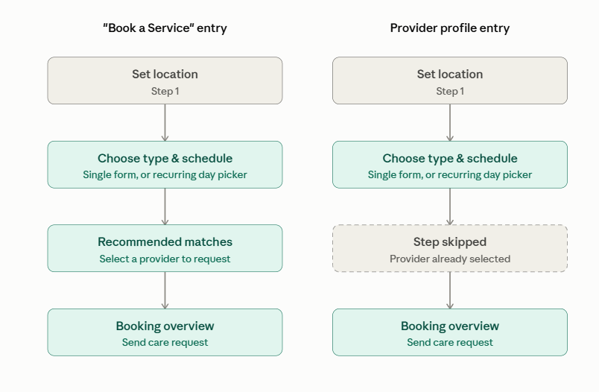
Carely’s two entry points share almost the same steps as sweepsouth, except the generic "Book a Service" flow includes a matching step that the "provider-first" flow skips, since the provider is already chosen. Here's that visualized, then the full step-by-step illustration below.
Figure 2 Different entrypoint to do a booking request

- Flow A : "Book a Service" (generic entry, no provider chosen yet)
Trigger: After clicking on “book a service” button in the home page of the Carely household/client dashboard
Step 1 — Location
- User sets the address/neighborhood where the service is needed.
Step 2 — Booking type & schedule
- User selects the service type (e.g. Babysitting, Indoor Cleaning, Indoor Cleaning, Outdoor Cleaning, Moving Cleaning, Laundry&Ironing, Elder care) and chooses Single session or Recurring.
- Single → shows the single-session form: date, time range, extra tasks (checkboxes specific to that service, e.g. "Inside Oven," "Playtime," "Medication Admin" per your SweepSouth image reference).
- Recurring → shows the day list (Mon–Sun, expandable rows like the SweepSouth reference): user selects which days apply, and for each selected day can independently set its own time range and extra tasks; this is exactly the "Mon/Wed 9–4 vs Sat 6pm–7am" flexibility we designed earlier, just presented as expandable day-rows instead of grouped blocks. Once days/times are set, show the calendar preview (highlighted generated dates, tap any date to skip it) as the review layer before continuing.
Step 3 — Matching & overview
- System shows a list of recommended matching providers based on service type, location, and the chosen schedule's availability.
- User selects one provider from the list or can let CARELY AI Assistant chose for them.
- A booking overview screen summarizes: provider, location, schedule (single date or full recurring list), extra tasks, estimated cost.
- Button: "Send care request" — not "Proceed to payment," since (per our earlier design) no payment is captured until the provider accepts.
- Flow B : Direct from a Provider's Profile ("Request Booking" button)
Trigger: After clicking on “request booking” button in the explore page precisely on a particular provider profile info overlay in Carely household/client dashboard
Step 1 — Location
- Same as Flow A: user sets the address.
Step 2 — Booking type & schedule
- Same component as Flow A: choose Single or Recurring.
- Recurring → same day-list + per-day time/tasks + calendar preview as Flow A.
- Single → same single-session form as Flow A.
Step 3 — Overview (matching step skipped)
- Since the provider is already known, there's no matches list hence goes straight to the booking overview: this specific provider, location, schedule, extra tasks, estimated cost.
- Button: "Send care request" to that provider.
Implementation note: shared components
Because Steps 1–2 are byte-for-byte identical in both flows, build them as shared, reusable components (LocationStep, BookingTypeStep, DayScheduleSelector, CalendarPreview, SingleSessionForm) rather than duplicating screens. The only thing that actually differs between the two flows is:
- Whether the Matches step renders at all (Flow A: yes → Flow B: skipped entirely, not just hidden).
- What gets passed into the final Overview: a provider to be chosen (Flow A, resolved after Step 3a) vs. a provider already fixed (Flow B, carried in from the profile the user tapped "Request Booking" on).
A clean way to model this in your routing: treat providerId as an optional parameter entering the shared flow. If it's present (Flow B), skip the matches screen; if absent (Flow A), the matches screen becomes mandatory and its output supplies providerId before reaching Overview.

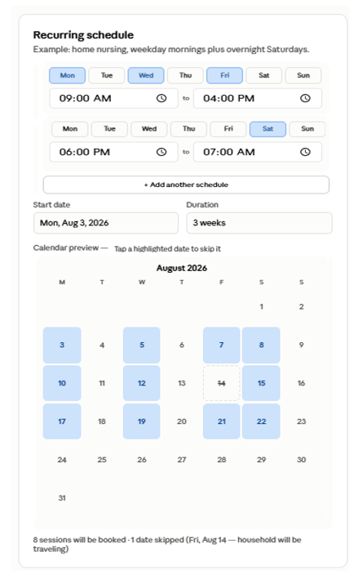
Figure 3 Carely old booking form prototype
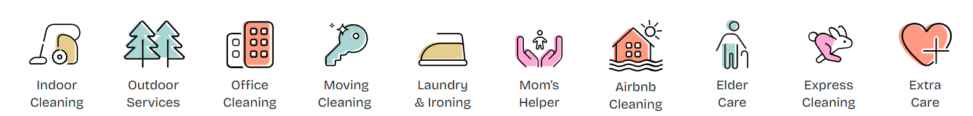
- SWEEPSOUTH APP SERVICES IN SOUTH AFRICA
Figure 4 Sweepsouth services

- SWEEPSOUTH BOOKING PROCESS
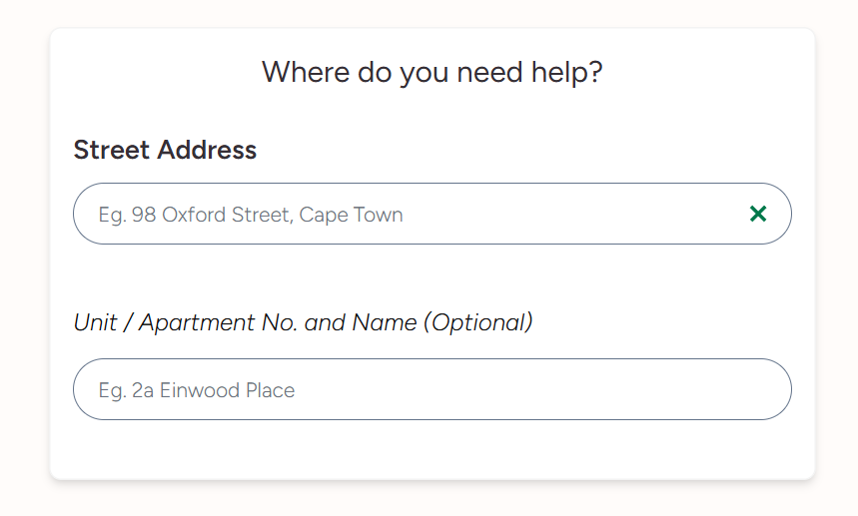
- STEP 0: SET THE LOCATION
Figure 5 Setting location page

When searching the street address we get possibilities of a drop down just like for YANGO app (if possible a map leaflet with the particular address pointed using a marker can be displayed)
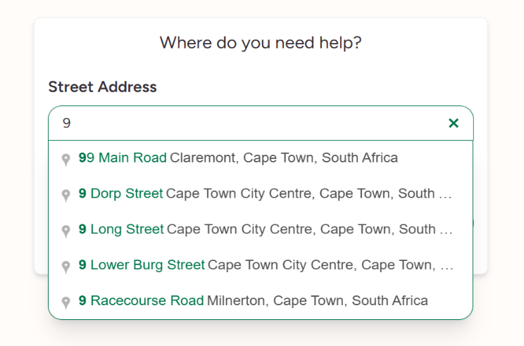
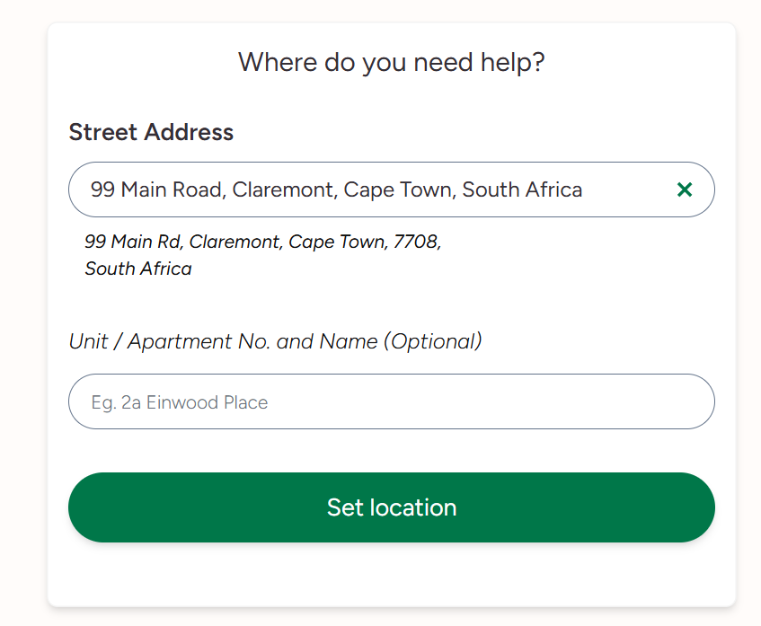
BEFORE
AFTER
Figure 6 Searching location

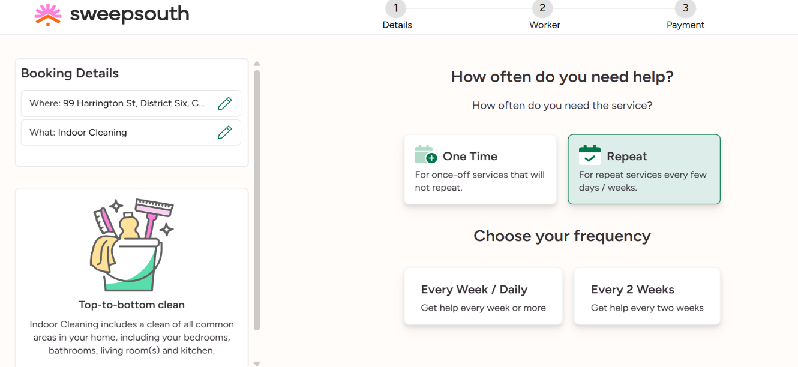
- STEP 1: CHOOSE THE BOOKING AND FILL THE DETAILS
Figure 7 Choose the booking type and frequency

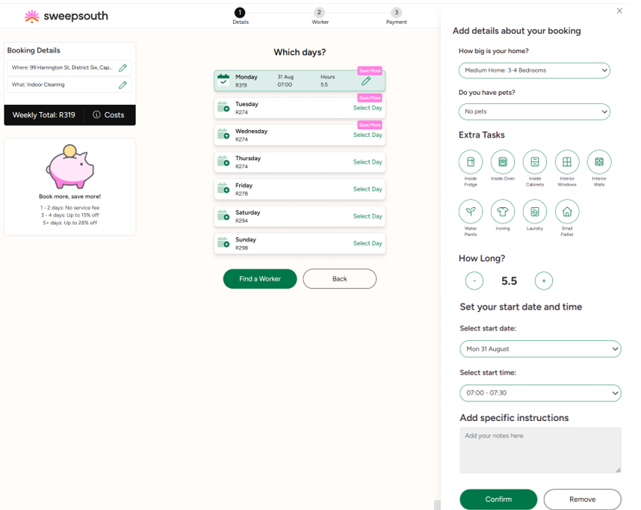
CASE 1: RECURRENT/RECURRING BOOKING
Figure 8 Select days and mention extra task
- STEP 2: FIND A WORKER
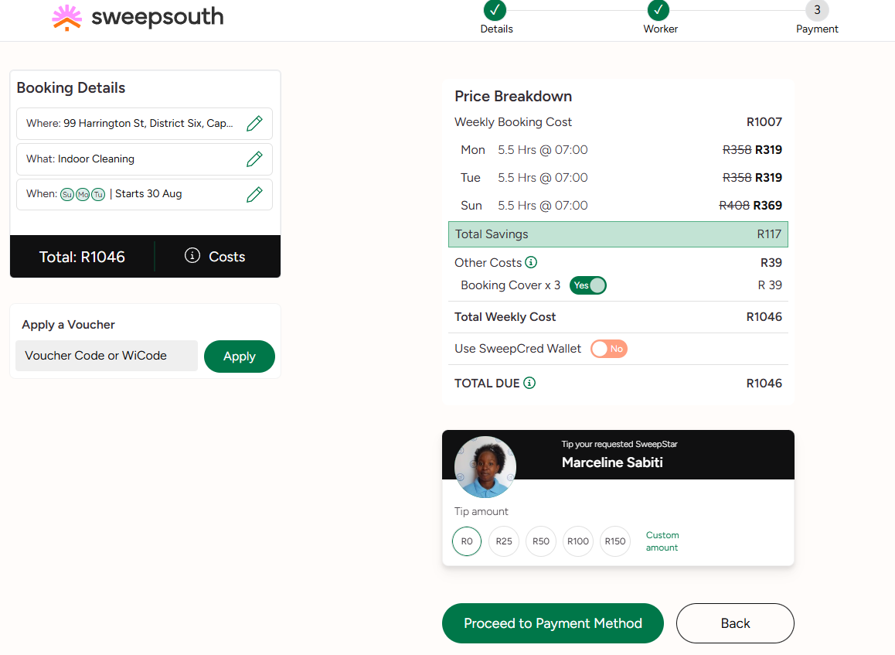
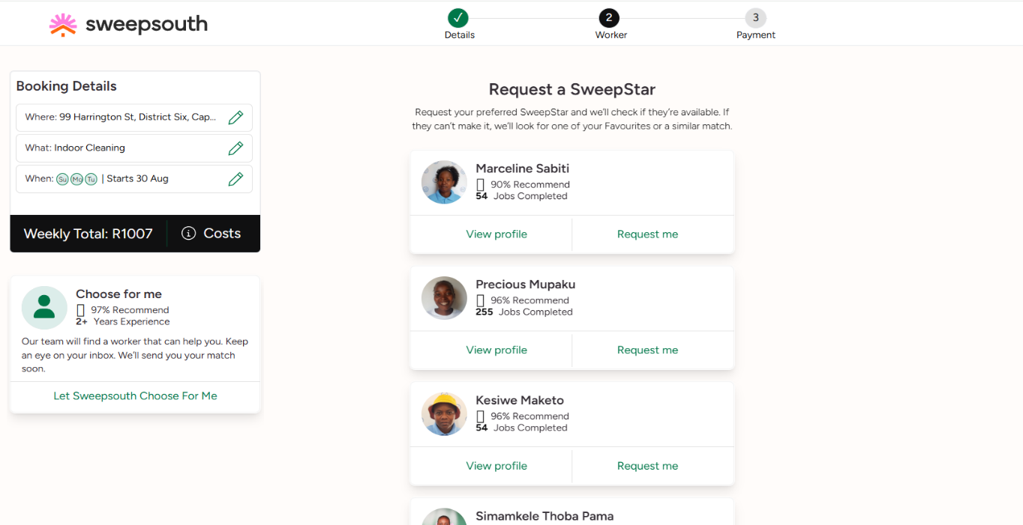
With the possibility that sweepsouth choose for you or you choose a worker for yourself
Figure 9 Price Breakdown overview
Figure 10 Choose among list of recommended matches

- STEP 3: PAYMENT
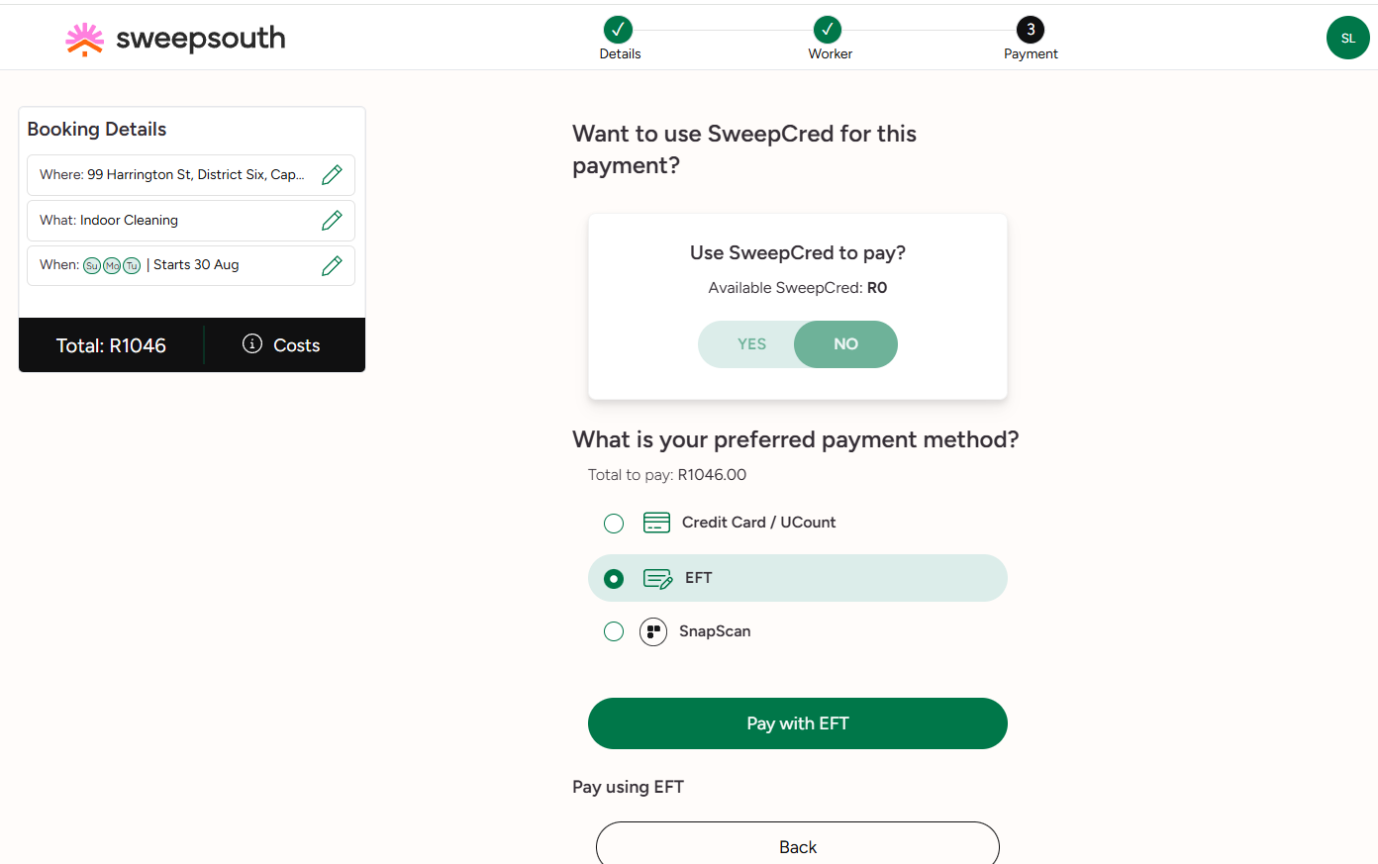
You can either pay using sweepcredit or credit card or mobile transfer.
Figure 11 Choose Payment method

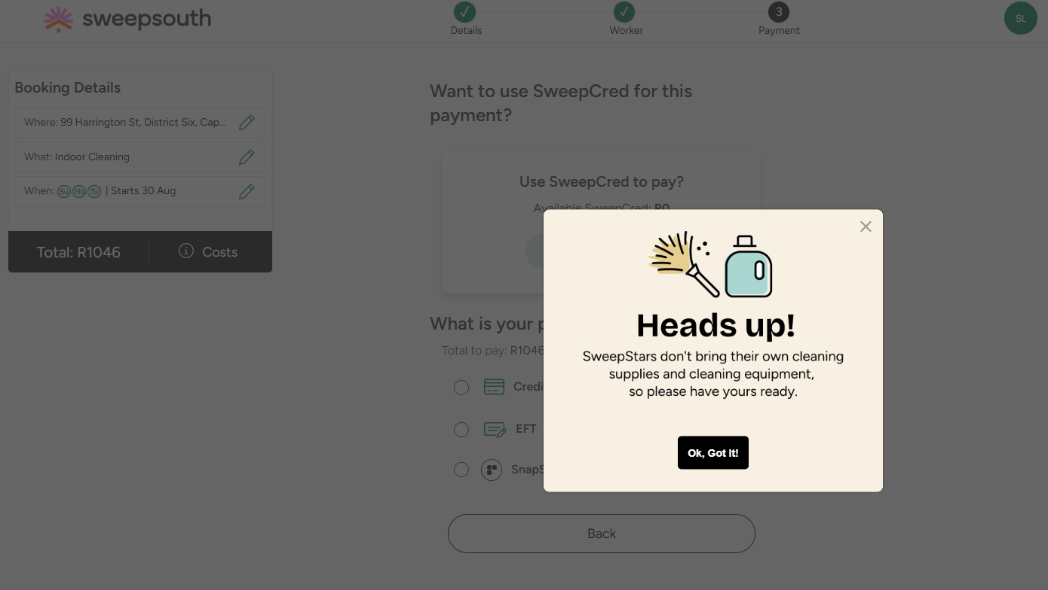
Note: The cleaner doesn’t bring their own cleaning supplies

CASE 2: BOOKING ELDERLY CARE
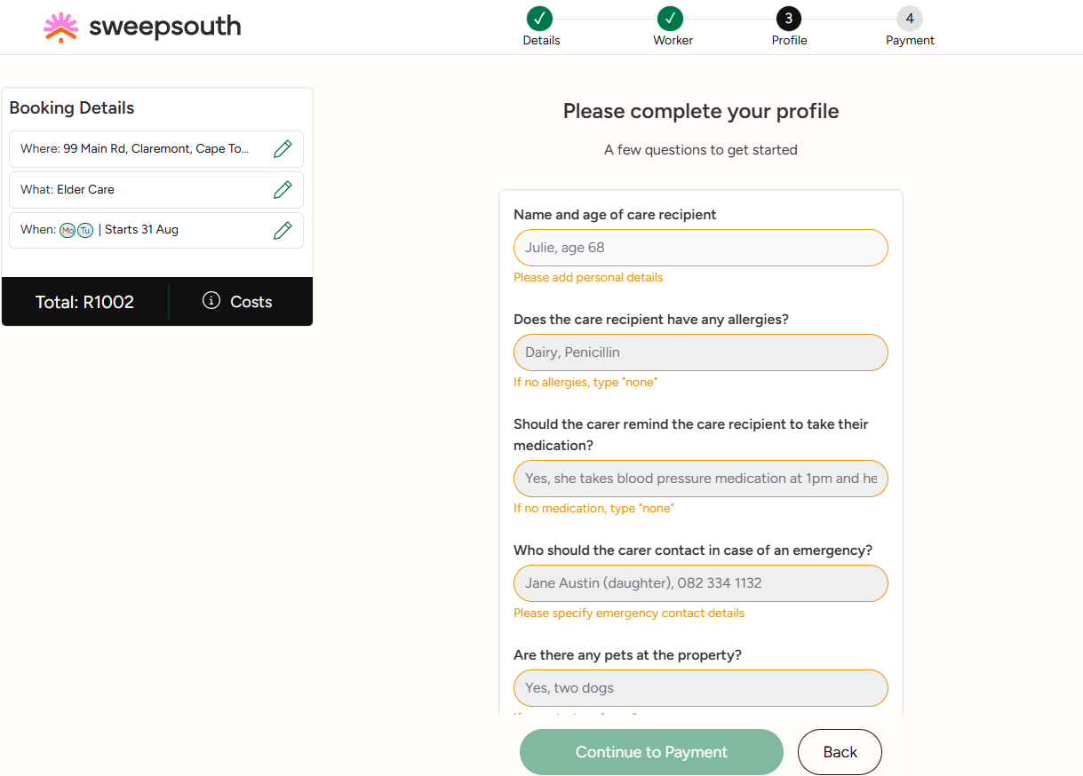
Instead of a proceed to payment button there is a complete profile button which when clicked brings you to step 3 (Profile) where you enter the infos of the elderly relative
Figure 12 Elderly care booking

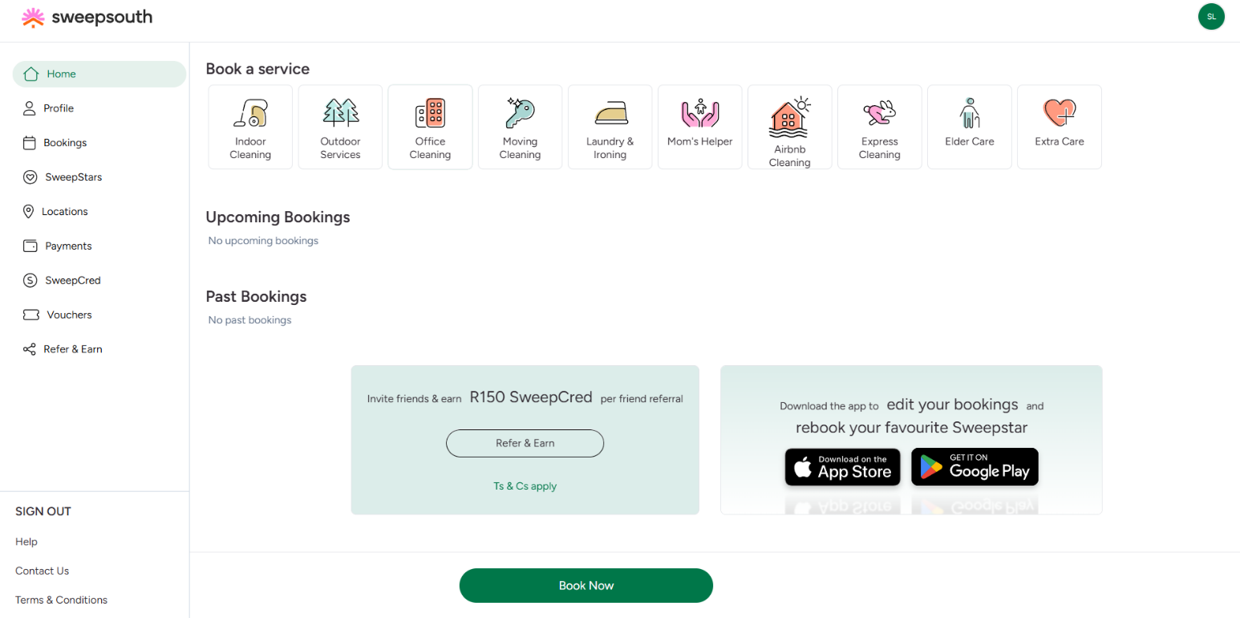
- SWEEPSOUTH CLIENT INTERFACE
Figure 13 Home Page

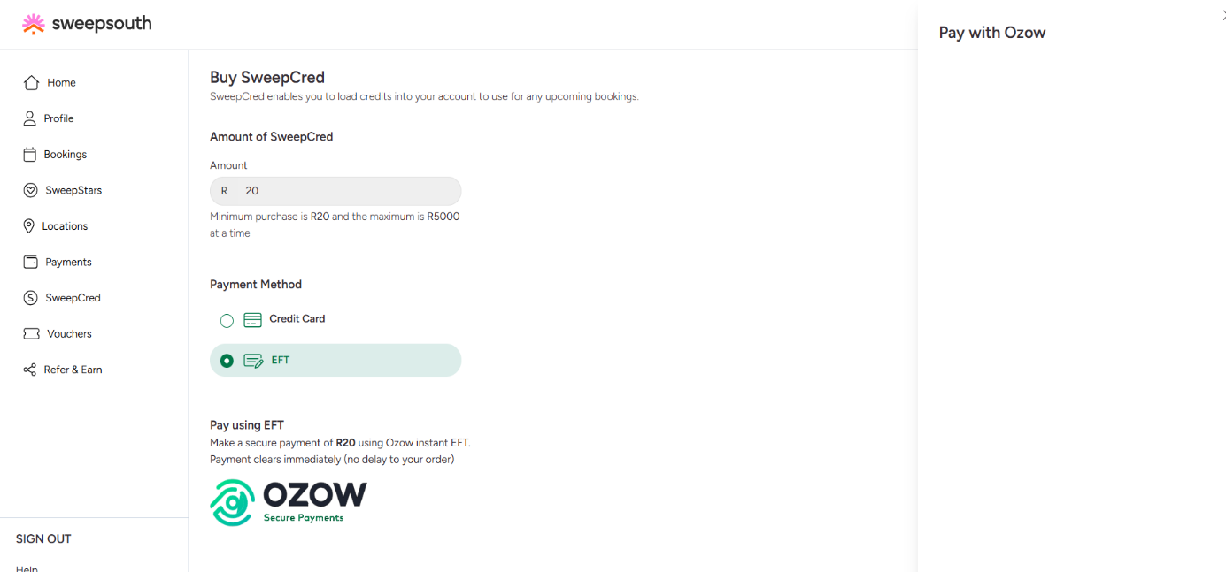
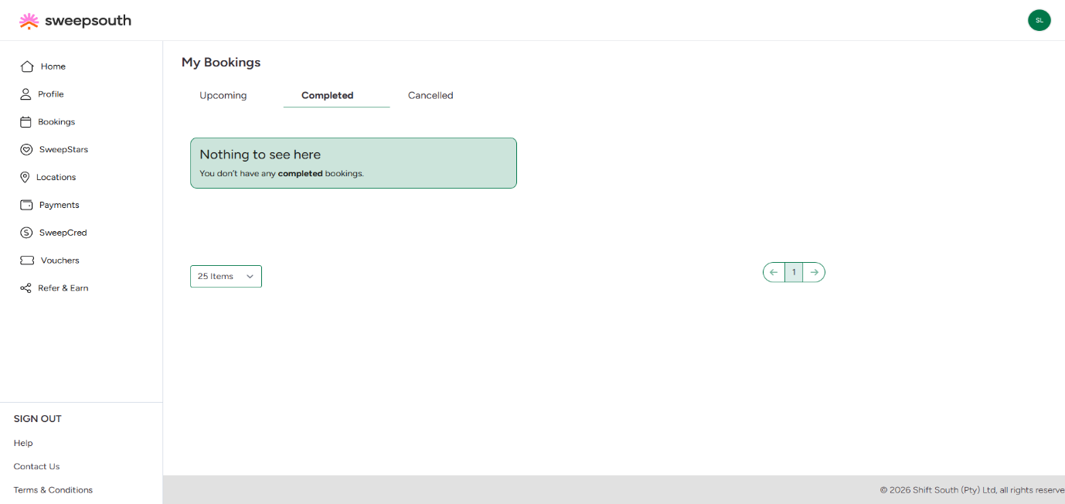
Figure 14 SweepCredit Page
Figure 15 Bookings Page

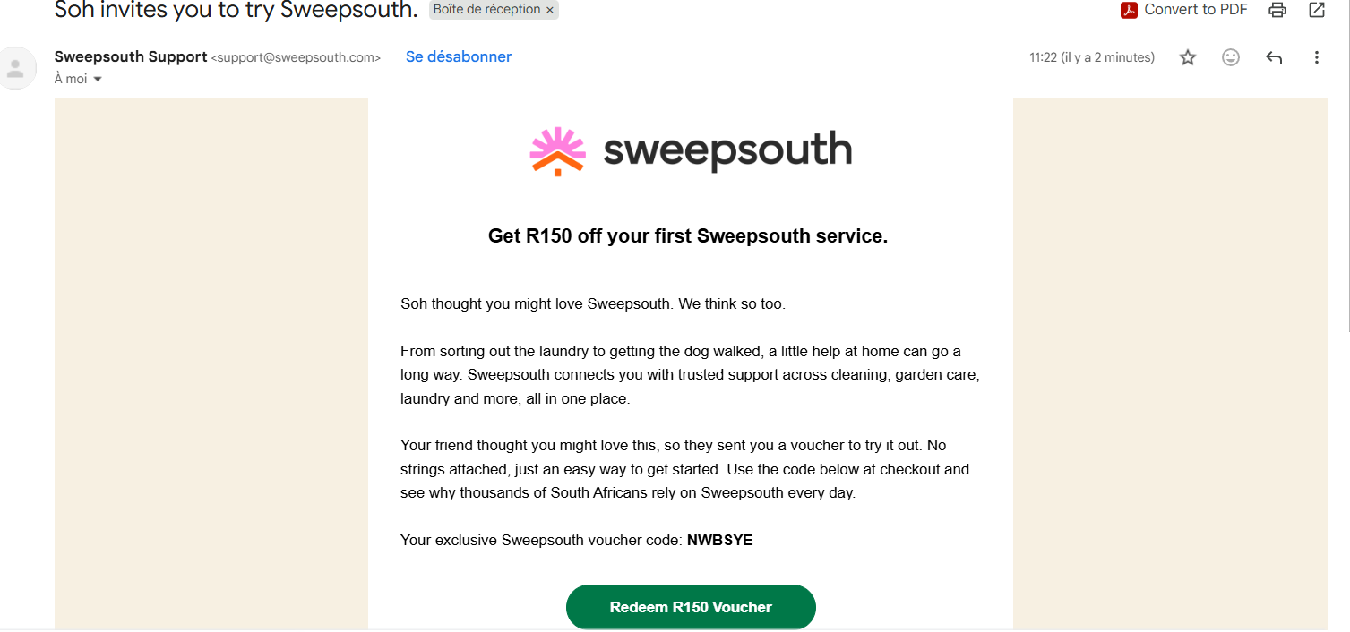
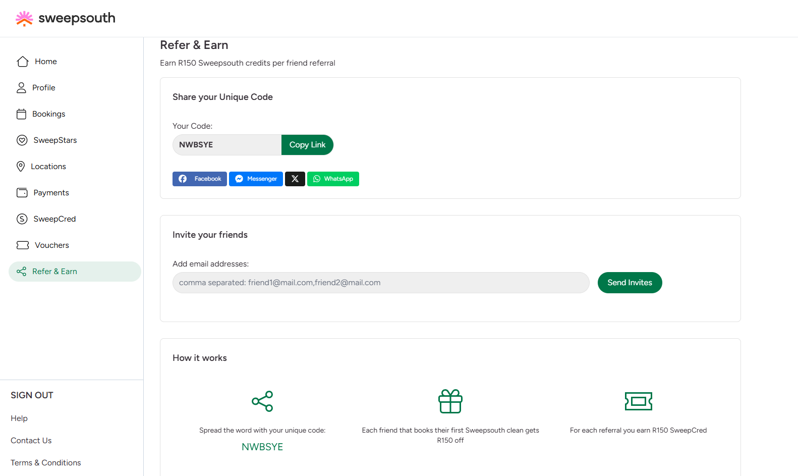
Figure 16 Sending codepromo/ voucher code via email to friend
Figure 17 Refer and Earn (Code promo)

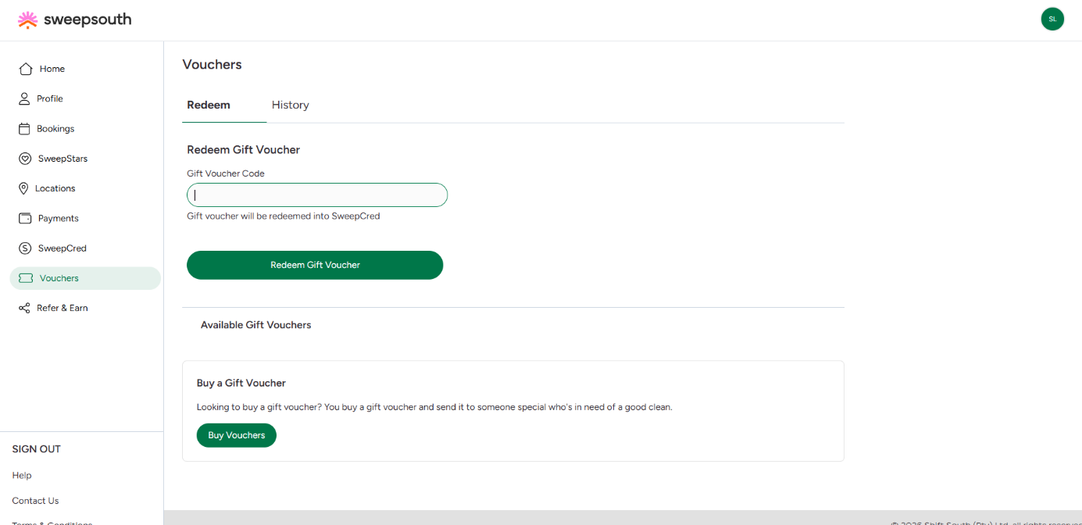
Figure 18 Voucher Page (transform yoour code promo to sweepcred)

- DIFFERENT TYPES OF EXTRA TASKS WHEN BOOKING

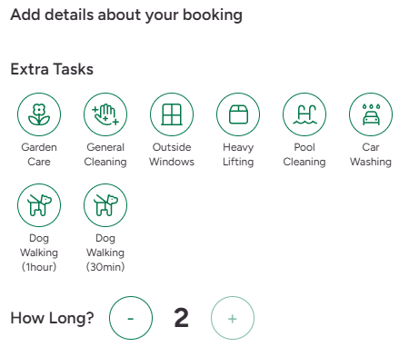
- Outdoor Cleaning Extra tasks

- Indoor Cleaning Extra tasks
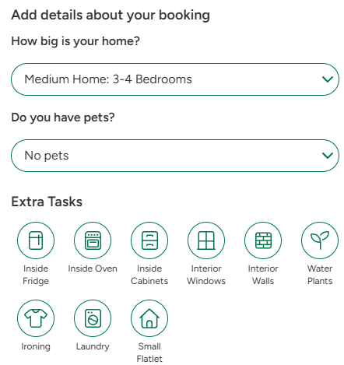

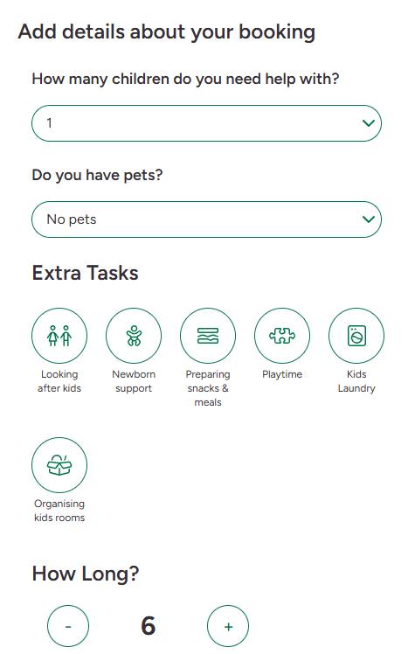
- Mother’s help/Babysitting Extra tasks

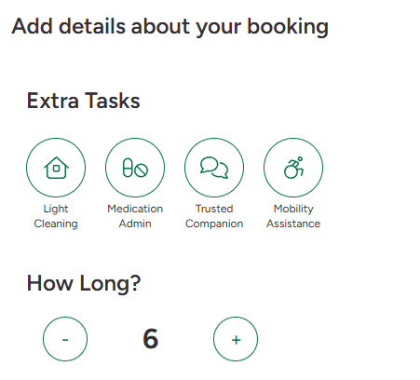
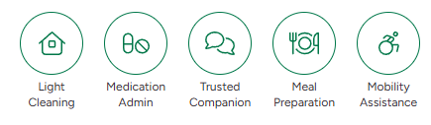
- Elderly care Extra tasks

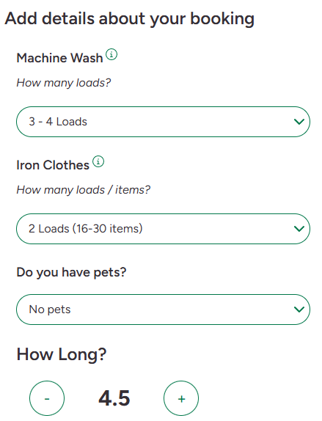
- Laundry and Ironing Extra tasks

